

***Arab American University***

***Faculty of Engineering and Information Technology***

***Computer Systems Engineering***

**SENIOR PROJECTII**

**Smart Restaurant**

**Aya Ghanem Talab Sawafta (201820042)**

**Saja Jehad Abed Sawaftah (201811496)**

**Supervised by: Dr. Rami Hadrob**

***Fall 2022-2023***

**Students Statement**

We, the undersigned students, certify and confirm that the work submitted in this project report is entirely our own and has not been copied from any other source. Any material that has been used from other sources has been properly cited and acknowledged in the report.

We are fully aware that any copying or improper citation of references/sources used in this report will be considered plagiarism, which is a clear violation of the Code of Ethics of the Arab American University.

**Aya Ghanem Talab Sawafta (201820042)**

**Saja Jehad Abed Sawaftah (201811496)**

**Supervised by: Dr. Rami Hadrob**

**Supervisor Certification**

**Computer Systems Engineering Dept.**

**Submitted in partial fulfillment of the requirements of B.Sc. Degree in Computer Systems Engineering.**

**Juley 2022**

This to certify that the work presented in this senior year project manuscript was carried out under my supervision, which is entitled:

" Smart Restaurant"

I hereby that the aforementioned students have successfully finished their senior year project and by submitting this report they have fulfilled in partial the requirements of B.Sc. Degree in Engineering.

I also, hereby that I have **read, reviewed and corrected the technical content** of this report and I believe that it is adequate in scope, quality and content and it is in alignment with the ABET requirements and the department guidelines.

***Dr. Rami Hadrob***

ACKNOWLEDGMENT

First of all, we thank God very much, for our arrival here. We would like to extend our sincere thanks and gratitude to everyone who helped us and stood by us to reach this stage and complete our graduation project. We thank Dr. Rami Hadrob, who was cooperating with us and was keen to keep our spirits very high, and we do not forget the family, who are always our first support, and all the loved ones and friends. Thank you to everyone who came to share these moments with us, may God help us and you always and forever.

ABSTRACT

Smart Restaurant is mainly interested in the order delivery system in cafes by automatically delivering customer orders in an efficient, fast and developed manner. It aims to create a new ordering method without wasting time waiting for waiters and customers. The idea is basically that the system takes orders and delivers them to the customers slots on the conveyor belt. To avoid any accidents from manual delivery, the system speed is constant which leads to stable performance.

TABEL OF CONTENTS

**LIST OF FIGURES** i

**LIST OF TABLES** ii

**LIST OF SYMBOLS AND ABBREVIATIONS** iii

**1CHAPTER 1: INTRODUCTION** 1

1.1Problem Statement and Purpose 1

1.2Project and Design Objectives 1

1.3Intended Outcomes and Deliverables 1

1.4Summary of Report Structure 2

**2CHAPTER 2: BACKGROUND** 3

2.1Overview 3

2.2Related Work 4

2.2.1 Tokyo Smart Restaurant 4

2.2.2 A Smart Restaurant Menu Ordering System Using Arduino 4

2.2.3 Implementation of Smart Restaurant with e-menu Card 6

2.2.4 To Build a Smart Unmanned Restaurant with Multi-Mobile Robots. 8

2.2.5 Table of comparison between existing system: 10

2.3summary: 12

**3CHAPTER 3: METHODS AND MATERIALS** 13

**3.1**Introduction**:** 14

3.2system requirements 15

3.2.1 functional requirements: 15

3.2.2 Non-functional requirements: 16

3.3Hardware Components: 18

3.4Development methodology: 24

3.4.1 Use case diagram: 24

3.4.2 Use case description: 25

3.4.3 sequence diagram: 27

3.4.4Algorithm:………………….. 28

3.4.5 Activity diagram: 30

3.4.6 Architectural diagram 33

**4CHAPTER 4: RESULTS AND DISCUSSIONS** 34

4.1Results 35

4.2Discussions 39

4.3 Challenges, modifications and problems ………………………………………………………………………………………40

**5CHAPTER 5: Project Management** 41

5.1Tasks, Schedule and Milestones 42

5.2 Resources and Cost Management 44

5.3Lessons Learned 45

**6CHAPTER 6: Impact of the engineering solution** 46

6.1Economical, Societal and Global 47

6.2Environmental and Ethical 48

**7CHAPTER 7: CONCLUSIONS and RECOMMENDATIONS** 49

7.1Summary of Achievements of the Project Objectives 50

7.2New Skills and Experiences Learnt 51

*7.3*Recommendations for Future Work 52

REFERENCES: 54

APPEDECIES………………………………………………………………………………………………………………….55

**LIST OF FIGURES**

*Figure page*

Figure 1 Flowchart of research methodology 5

Figure 2 System Operation 6

Figure 3 The robots execute the task 4 and reach the target points. 8

Figure 4 Two robots move to the different target points. 8

Figure 5 Two robots move to the same target point. 8

Figure 6 Conveyor 16

Figure 7 Ln298 Driver 16

Figure 8 H-Bridge 17

Figure 9 Arduino Mega 17

Figure 10 LCD 17

Figure 11 IR sensor Module 18

Figure 12 LEDs 18

Figure 13 Push Buttons 19

Figure 14 RFID 19

Figure 15 Keypad 4*4 20

Figure 16 power supply 20

Figure 17 Ultrasonic Distance Sensor 20

Figure 18 ESP8266 Module 21

Figure 19 wires 21

Figure 20 Use case diagram 22

Figure 21 App sequence diagram 25

Figure 22 Customer's system sequence diagram 25

Figure 23 Flowchart algorithm for k-bad system 26

Figure 24 Flowchart algorithm for app 27

Figure 25 App activity diagram 28

Figure 26 Customer's system activity diagram 29

Figure 27 Tray activity diagram 30

Figure 28 Architectural diagram 31

Figure 29 MS Project 1 33

Figure 30 MS - Project 2 33

Figure 31 MS-Project3 34

**LIST OF TABLES**

*Table Page*

Table 1 Robot Task Assignment 7

Table 2 Related work compression 10

Table 3 Enter Order Description 23

Table 4 Get Order Description 23

Table 5 Deliver Order Description 24

Table 6 Request Order Description 24

Table 7 total cost 35

**LIST OF SYMBOLS AND ABBREVIATIONS**

|  |  |
| --- | --- |
| **LIST OF SYMBOLS** | |
| **#** | Number sign |
| **$** | Dollar Sign |
| **LIST OF ABBREVIATIONS** | |
| **LCD** | Liquid Crystal Display |
| **RFID** | Radio-Frequency Identification |
| **USSD** | Unstructured Supplementary Service Data |
| **PDA** | Personal Digital Assistant |
| **LAN** | Local Area Network |
| **C#** | (C-Sharp) Programming Language |
| **L298N** | **Motor Driver Module** |
| **LED** | Light-Emitting Diode |
| **ESP** | Electronic Stability Control |
| **UML** | Unified Modeling Language |
| **App** | Application |
| **K-PAD** | Key-bad |
| **MS-Project** | Microsoft Project |

1. **CHAPTER 1: INTRODUCTION**
   1. Problem Statement and Purpose

Waiting queues in any store , market or restaurant is one of the most frustrating problems people have when they want to get something. We took this issue as a major concern while building a smart restaurant. There is a clear objective here to avoid human errors and time wasted during the delivery and ordering process. The smart restaurant has a variety of features that support our goals of going for a new experience within the delivery system in cafes. Automated and seamless delivery process is what we offer With several ordering methods to suit the needs of customers with regards to their different generations, we have made ordering and delivery clear and easy with much less possibility of error in our method of handling orders.

* 1. Project and Design Objectives

Our approach aims to achieve the main goal of developing the ordering process in cafes, making it easier to deal with it, and making it easier to obtain orders. Our system will be used by cashier waiters and cafe customers. We target both categories as they both require a more efficient way to place and deliver orders. The system reduces pressure on the cashier due to the availability of automated ordering methods, and there is still the ability for those who prefer traditional direct ordering.

Customers are pleased in many ways to order, and for each of them Preferred method.

There are three ways to apply:

1. System keyboard and screen.

2 . Smart Restaurant mobile application.

3 . Direct ordering from customers to cashier.

* 1. Intended Outcomes and Deliverables

The desired result of the project is to create a technologically advanced smart restaurant system in which we try to emulate the basic concept adopted in cafés and restaurants in terms of ordering and placing orders with new added features that help facilitate the process for system users, waiters, cashiers and customers by having easy to use ways to order, verify and deliver orders . Applications can be submitted via: key-bad and screen, mobile app, or manually. These different sorting methods are divided into three queues so that each method has its own queue. There are no similar systems in our area, so we tried to introduce this idea in our own.

* 1. Summary of Report Structure

This report is divided into seven chapters. In the first chapter, we briefly discuss an introduction about our project. In the second chapter, we conduct a literature review and point to previous projects with the same topic and how our project differs from other ones. Chapter three (Methods and Materials) describes in detail the tools and technology used to achieve our final project. In chapter four (result and discussions), we talk about the final results of our project and discuss them. In chapter five (project management), we talk about the tasks we performed to finish this project, and we will show the cost of the projects. In chapter six (impact of the engineering solution) we will talk about the impact of our project on the environment and does it have an economic and social impact. The last chapter (conclusions and recommendations) we will mention what we can do in future work and our recommendations.

1. **CHAPTER 2: BACKGROUND**
   1. Overview

In this chapter, we will discuss existing systems that are close to our project or similar in the main functions of our system facilities. The idea of our project is not new, there are similar projects, of course. Automating the process of delivering orders to customers in restaurants and cafes is not new in all Asian countries. The food delivery express is well known among sushi restaurants and used in other cuisines as well.

Our goal is to develop the cafes and restaurants system to suit modern technology. This delivery system is planned to be applied on a larger scale so as to serve a larger number of people.

## Related Work

### Tokyo Smart Restaurant

Tokyo Restaurant has human chefs like any restaurant, but this restaurant does not need waiters. Where the customer orders his order through an application, and when his order is ready, it is placed on a conveyor belt that reaches their table. Payment is also automated. Through a specific technology, the number of people present in the restaurant is determined and stored in data, and it reaches the chefs in the kitchen to inform them what the meals are and their number, then put them on the conveyor belt to reach the customer. [1]

### A Smart Restaurant Menu Ordering System Using Arduino

There are a lot of restaurants nowadays, the common method of ordering in a restaurant involves the customer selecting their order and waiting for it to be ready. However, there are many customers who feel dissatisfied with some cases that may occur in restaurants, such as delays in delivering orders, customer orders that do not match, and the long time consumed during the process of registering the customer's order and the payment process. Advanced techniques can be used to avoid these cases. This restaurant came to provide a solution to some of these cases, as it includes the use of LCD screens for the process of arranging the menu in restaurants. And because there may be a delay in payment as well as cash exchange on hand. This system provides other payment methods, such as using RFID and USSD cards, as well as using the LCD screen to display the available menu and to process the order. [2]

Flowchart of methodology:

The flowchart below is showing the step to conduct this study.

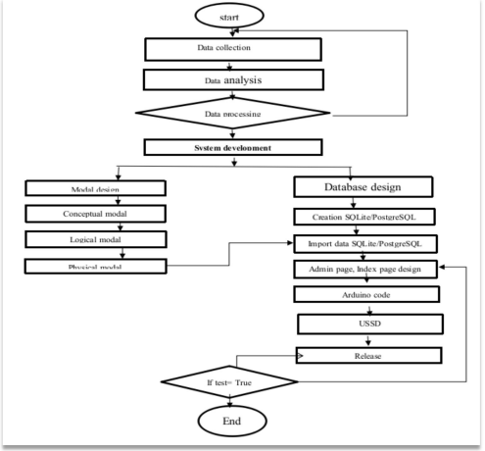

Figure 1 Flowchart of research methodology

### Implementation of Smart Restaurant with e-menu Card

### Since we have reached the days of technology and almost everything is based on technology, restaurant owners also decided to use technology. The technology used here is the PDA with a touch screen and the local wireless network, in order to dispense with the traditional paper method and replace it with the PDA. A smart touch screen is placed on the customers’ tables containing an Android application and linked directly with the kitchen screen through the local wireless network to reach Straight to the chefs. Orders from customers will instantly reach the kitchen unit. The benefits of this technology used here are:

### Ease of obtaining the customer’s request due to the ease of use of the application.

### Avoid human errors that occur between the customer and the waiter.

### Less cost, as here the money and cost are invested once, which is when purchasing the equipment, and the waiters will not be paid continuously because they are not present. [3]

### Flowchart for understanding the system operation.

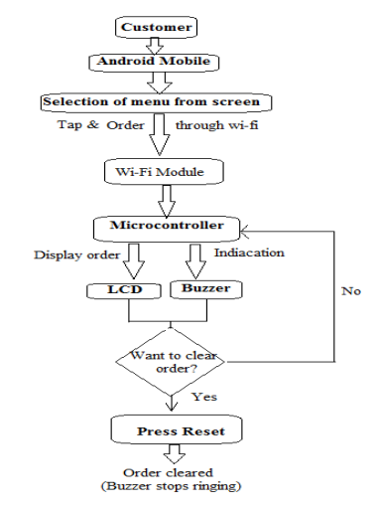

Figure 2 System Operation

### To Build a Smart Unmanned Restaurant with Multi-Mobile Robots.

### This study includes building a smart restaurant by having many robots interacting with each other. MATLAB software is used as a platform, and to simulate the effect in the end Vision C# is used as a design tool. The number of robots is set according to the number of guests, and the system will choose the robot closest to the task based on the decision-making process, and it will plan the route using the particle crowd optimization tool to get the most speed. And the global search ability is enhanced so that the robots can interact with each other to be able to perform many tasks such as hosting guests automatically, delivering food, cleaning the table, and many additional tasks in the restaurant. [4].

This table show Robot Task Assignment :

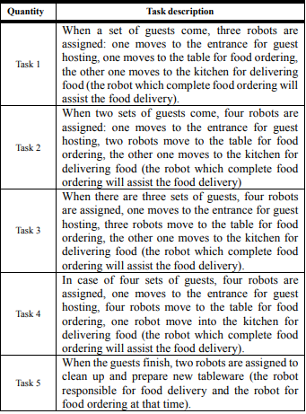

Table 1 Robot Task Assignment

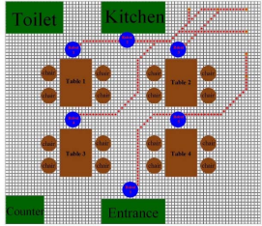

Figure 3 The robots execute the task 4 and reach the target points.

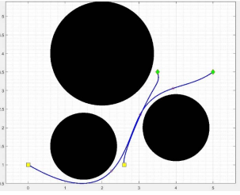

Figure 4 Two robots move to the different target points.

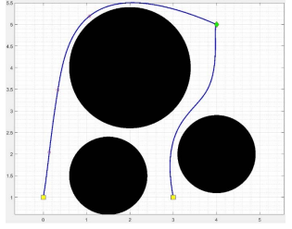

Figure 5 Two robots move to the same target point.

### Table of comparison between existing system:

|  |  |  |  |  |  |  |  |  |
| --- | --- | --- | --- | --- | --- | --- | --- | --- |
| Differences  Name of system | Used Technology | Price | Producer Country | | Production Year | Targeted Customers | | Main Strengths |
| Smart Restaurant | Mobile Application  Automated  transmission system. | 350$ | Palestine | 2022 | | | Customers of restaurant | * no need of a person to take the order from the table. * Save time and effort. * Accuracy and efficiency in obtaining the order without mixing with other orders. * Automated payment. * Mainly using technology. |
| Tokyo Smart Restaurant | Mobile Application  Automated payment.  Technology monitor how many people are sat & what eating.  Know the type of dishes by technology. | Not Ava. | Japan | 2013 | | | Customers of restaurant | * no need of a person to take the order from the table. * Save time and effort. * Accuracy and efficiency in obtaining the order without mixing with other orders. * Automated payment. * Mainly using technology. |
| A Smart Restaurant Menu Ordering System Using Arduino | Mobile Application  Menu ordering process by integrated & network system.  Using automate payment. | 513$ | Ruhengeri Rwanda | 2021 | | | Customers of restaurant | * no need of a person to take the order from the table. * Save time and effort. * Automated payment. * Mainly using technology. |
| Implementation of Smart Restaurant with e-menu Card | Mobile Application.  Screen on the kitchen connects directly with customer tablet. | 110$ | India | 2015 | | | Customers of restaurant | * no need of a person to take the order from the table. * Save time and effort. * Accuracy and efficiency in obtaining the order without mixing with other orders. * Automated payment. * Mainly using technology. |
| To Build a Smart Unmanned Restaurant with Multi-Mobile Robots. | Mat-lab platform  C# simulation  Multi-robots | Not Ava. | Pingtung, Taiwan | 2018 | | | Customers of restaurant | * No need for human(according to technology time is strength). * Save time and effort. * Save time and effort. * Accuracy and efficiency in obtaining the order without mixing with other orders. |

Table 2 Related work compression

## summary:

Relay on previous work, we noticed that all of the works is related to smart restaurants. We noticed that in every works there is something different from the other in some characteristics, but they all lead to almost the same goal, which is the automatic transmission system based mainly on technological development.

# **CHAPTER 3: METHODS AND MATERIALS**

## Introduction**:**

الترجمة طويلة جدًا ولا يمكن حفظها.

In this chapter, we will show the architecture of the system and explain how it works. We also go through all the hardware components that will be used in our system and explain them. In addition, we will discuss the flowcharts that our system uses to perform its functions, and we will program the system using those flowcharts.

## system requirements

### functional requirements:

1. The system shall have two users cashiers /waiters and customers.

2. The system should provide three ways of ordering for customers which are system users, mobile application users and manual users.

3. The user's system shall provide a key-bad , LCD and button to enable customers to make their orders.

3.1 The button shall be pushed by customers to start the operation of ordering.

3.2 The LCD shall preview a menu items as numbers from 1 to 7, then displayed each item with its quantity and total price.

3.3 The key-pad shall provide the ability to customers to enter then to Edit or cancel the order while the order isn’t confirmed yet.

4. the application shall provide a menu and about us sections that appears when the user click ”Get started” button.

4.1 The menu's screen shall show the items of cafe menu. Initially all items are not ordered so their price is 0-Nis.

4.2 The application shall enable customers to place order as many items as they want and there is a total price is shown.

4.3 the application shall connected to real-time database on the Firebase, the firebase is connected to the system by the ESP8266 module through wife.

5. The cashiers side shall consists of 1 LCD,4 leds and 4 buttons.

5.1 the leds shall use as indicators so the first three leds when lighted this indicates that orders being received from customers slots and the last one is an indicator for the system tray as a delivery confirmation.

5.2 The first orange LED is an indicator of the LCD system so that it lights up when the customer confirms his order from the LCD system, and when the waiter presses the button below this LED, the order is displayed on the screen.

The green LED is an indicator of the mobile application, so that the waiter presses the button below this LED, and this LED starts flashing, and this means that the system is checking if there is an order from the mobile application or not. If it lights up, it means there is order, and if it turns off, it means that there are no orders.

The yellow LED is an indication of the manual order so that when the waiter receives an order from a customer in the traditional way, he presses the button so this LED lights up.)

5.3 The last button ”GO - Red button” shall enable the system tray to start delivering the orders.

5.4 The red LED should be an indicator if a customer tries to take someone else's order.

6.The system shall have tray which it is the main component in the delivery process it consists of three partitions for the system slots.

6.1 Each part of tray shall have a led which corresponds to one of the slots of system.

6.2 each part of tray shall have special card.

6.3 The tray shall moves on conveyor belt whenever it gets the confirmation to go from the cashier.

6.4 The tray shall stop at the slot whose corresponding led is lighted and waits the customer to scan their card with the reader for a certain time.

### Non-functional requirements:

1. Reliability: System failure is unacceptable, and once it is in order, it must be taken and prepared.

2. Ease of use:

2.1 The application allows customers to place their orders in a simple and user-friendly way

2.2 There is a printed menu next to the Key-bad.

2.3 The traditional method has been reserved for those who do not have the ability to use the system or the application.

3. Security: the tray turns the corresponding LED off when the customer scans the card (Unfortunately, the card did not work) .

4. Accuracy: delivering customers’ orders automatically in an efficient and fast way.

5. Performance: The system must respond with the result in real time and system speed is consistent which leads to a stable performance , and our system save time and effort.

## Hardware Components:

Our system will mainly built with these tools:

1. Conveyor belt : We will use a conveyor belt with two directions moving forward and backward to deliver the order to customers. .[5]

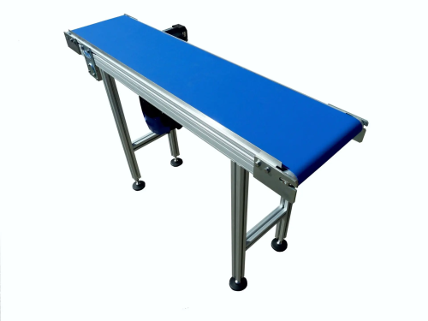

Figure 6 Conveyor

1. Ln298 Driver: This **L298N Motor Driver Module** is a high power motor driver module for driving DC and Stepper Motors.[6]

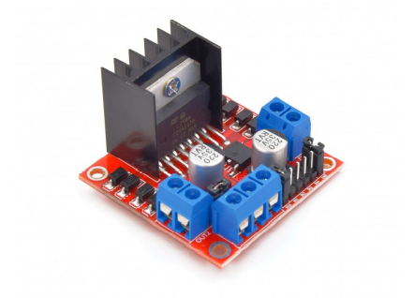

Figure 7 Ln298 Driver

1. H-Bridge: we will use it to connect between the conveyor dc motor , the Ln298 driver and the Arduino in order to control the direction of the conveyor .[7]

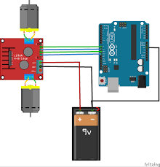

Figure 8 H-Bridge

1. Arduino Mega : Arduino mega micro-controller board is to control the whole system.[8]

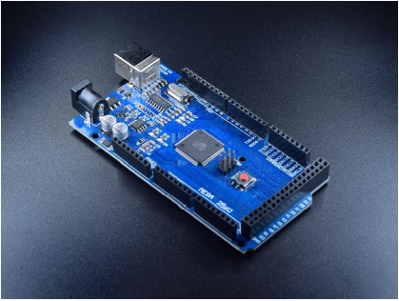

Figure 9 Arduino Mega

1. LCD 40*2 : We will use 2 LCDs in our system, one in the customer side and the other in the waiter side. The LCD in the customer side preview the menu and as numbers from 1 to 7, and number of orders of the menu item, it shows also the price and total price of the final order. The LCD in the waiter side, is to show the customer's orders to be placed in the specified slots of the tray .[9]

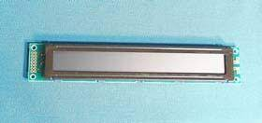

Figure 10 LCD

1. IR Module : The IR sensor is used to detect the customers taking the order from the slots.[10]

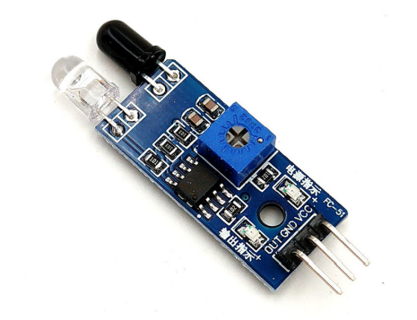

Figure 11 IR sensor Module

1. LED : LEDs are used as indicators for all of the system users through the process of ordering and delivering.[11]

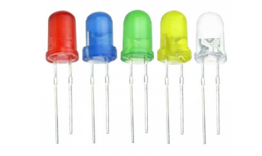

Figure 12 LEDs

1. Push Button :We will use push buttons in the customer side -System user slot- and in the waiter side. The button of the customer side to let customers start place their orders. While the buttons in the waiter side is to preview the order of the corresponding slot and let the tray Go ahead.[12]

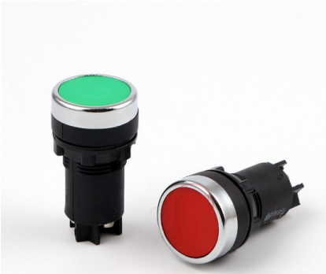

Figure 13 Push Buttons

RFID Reader : To make the order secure, we will put an RFID module in every slot, to let the customer scan it in his own slot, Every card only scan its own slot.[13]

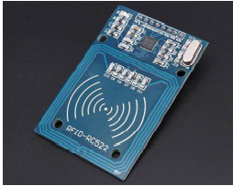

Figure 14 RFID

1. Keypad : we will use it In the System user slot, the customers can place their orders by using Keypad and confirm or cancel them.[14]

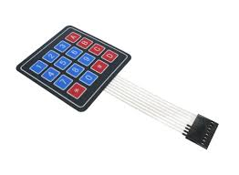

Figure 15 Keypad 4*4

1. Power Supply [15]

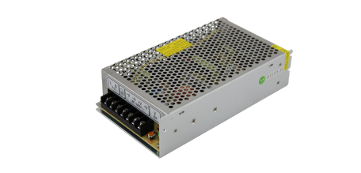

Figure 16 power supply

1. Ultrasonic : A measurement sensor, to measure the distance between the tray and the slot.[16]

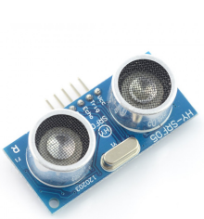

Figure 17 Ultrasonic Distance Sensor

1. ESP8266 : A module for connecting the Firebase real-time database to the system using Wi-Fi .we use Arduino IDE to program the ESP8266 CPU and its Wi-Fi components.[17]

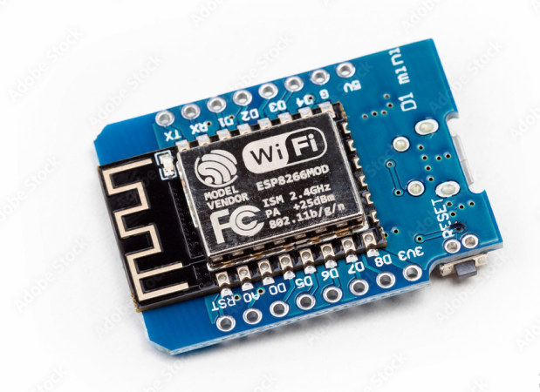

Figure 18 ESP8266 Module

1. Wires : Wires with different types are used to connect component.[18]

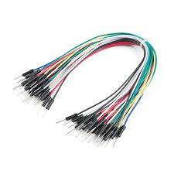

Figure 19 wires

Learn more at Appendix A

## Development methodology:

### Use case diagram:

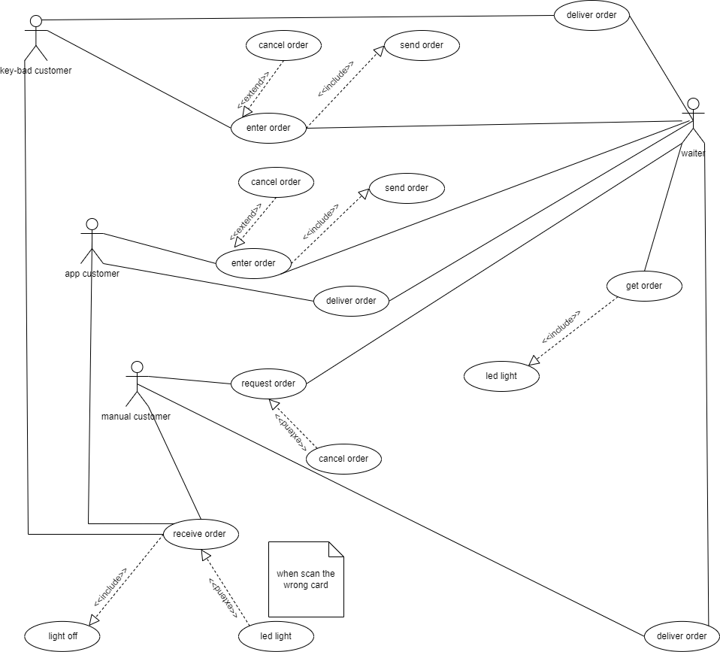

Figure 20 Use case diagram

|  |  |
| --- | --- |
| System | Smart restaurant |
| Use case | Get order |
| Actors | Customers(key-bad / app / manual)/waiter |
| Description | In the customer system, the waiter receives the order, when the order arrives, the LED of the customer system lights up, the waiter prepares the order and puts it into the customer system slot in tray. The same scenario happens in the application, the order reach to the waiter and the LED of the app system lights up , then the waiter puts the order into the customer app slot in tray |

### Use case description:

|  |  |
| --- | --- |
| System | Smart restaurant |
| Use case | Enter order |
| Actors | Customers(key-bad / app / manual) |
| Description | The request through the key-bad includes pressing the number that represents the request, determine the quantity and you can add another items. Then send the request. As for ordering through the application, it includes choosing the menu option that show orders, then the customer specify quantity then pressing Confirm to send the request. For manual, the customer communicates directly with the waiter. |
| Stimulus | When the customer decides to order, our system with both methods (key-pad and app) will show the menu. |
| Response | The menu will be printed next to key-bad, when the customer enters his order number, his order will appear on the LCD with the price, then he can confirm his order to send it.  When the customer chooses his order from the list in the app, the price will appear, then he can confirm his order and send it. |

Table 3 Enter Order Description

Table 4 Get Order Description

|  |  |
| --- | --- |
| System | Smart restaurant |
| Use case | Deliver order |
| Actors | Customers(key-bad / app / manual)/waiter |
| Description | In the customer system, when the customer confirms his order and sends it, his order arrives to the waiter organized by Arduino. The same scenario for the application, but the difference is that in the application there is a real database to which the request reaches first before it reaches the waiter. |
| Stimulus | When the order, our system with both modes (key-pad and app) will show the order on the waiter's screen. |

Table 5 Deliver Order Description

Table 6 Request Order Description

|  |  |
| --- | --- |
| System | Smart restaurant |
| Use case | request order |
| Actors | Customers(key-bad / app / manual)/waiter |
| Description | In the direct order system, the customer request his order directly from the waiter, and the waiter will place his order in the desired slot of the direct order system. |

### sequence diagram:

The sequence diagram is the part of the UML diagrams so from the sequence diagrams we will show the behaviors of our system how will it be.

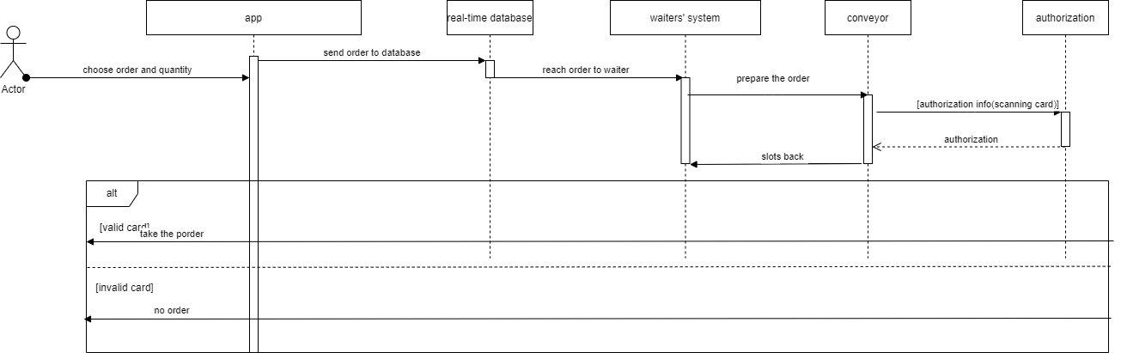

Figure 21 App sequence diagram

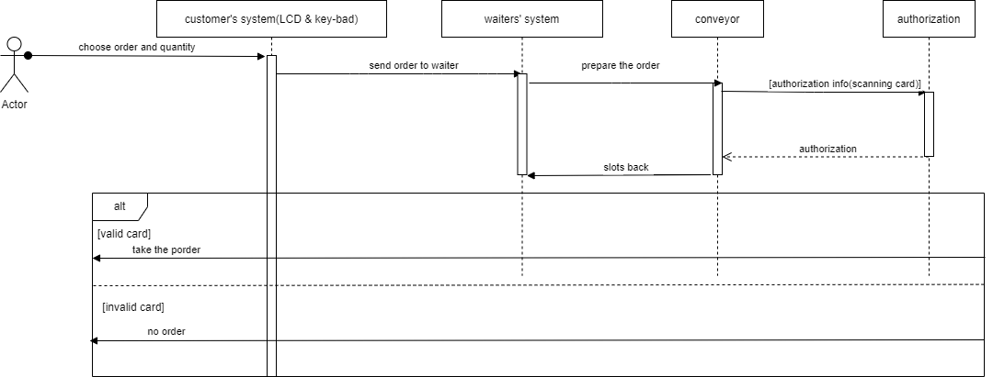

Figure 22 Customer's system sequence diagram

### Algorithm:

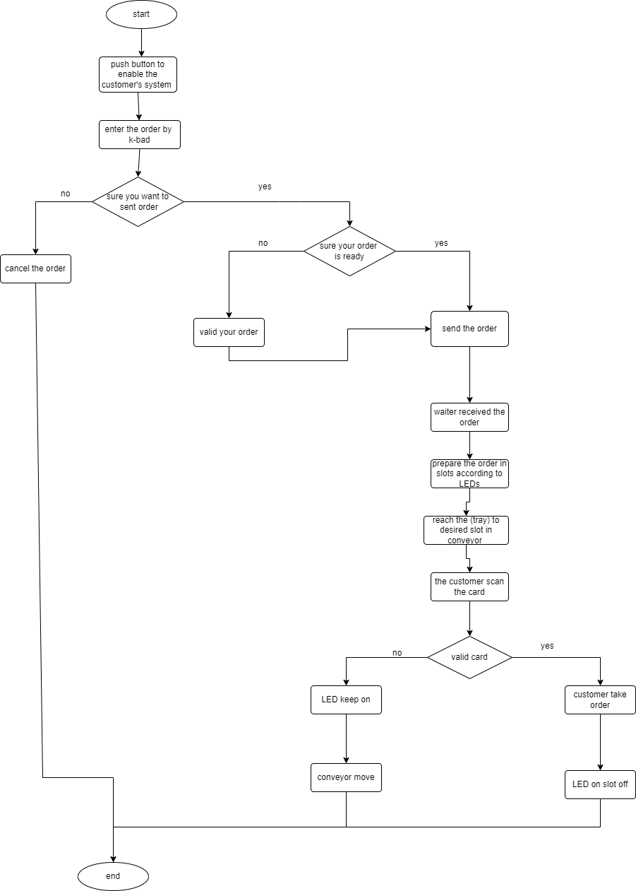

Figure 23 Flowchart algorithm for k-bad system

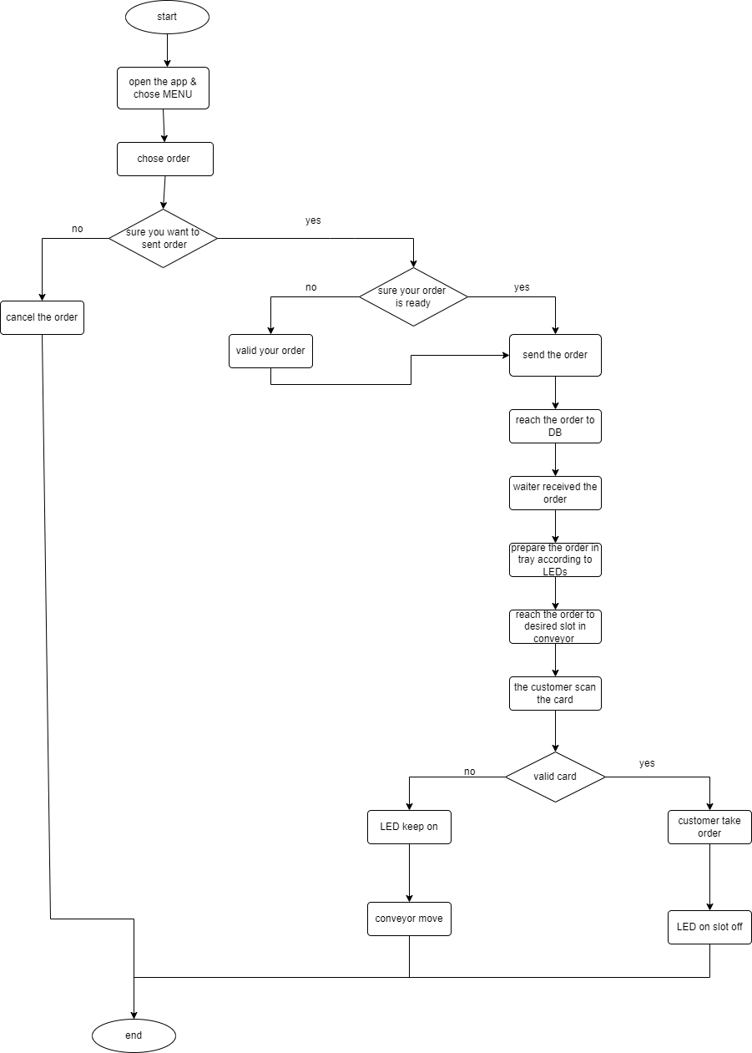

Figure 24 Flowchart algorithm for app

### Activity diagram:

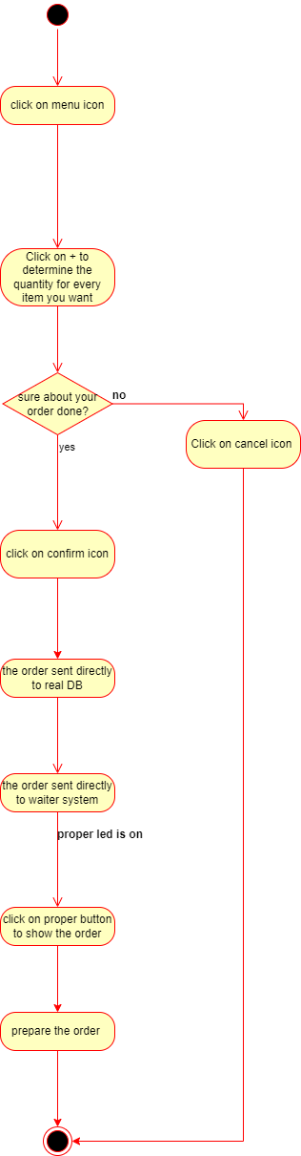

Figure 25 App activity diagram

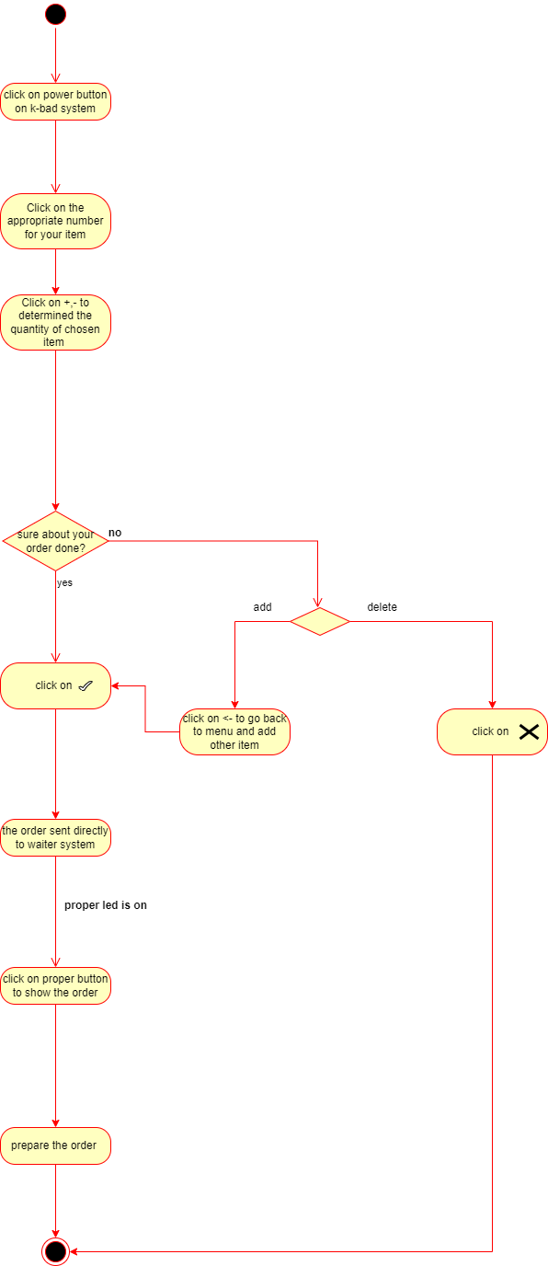

Figure 26 Customer's system activity diagram

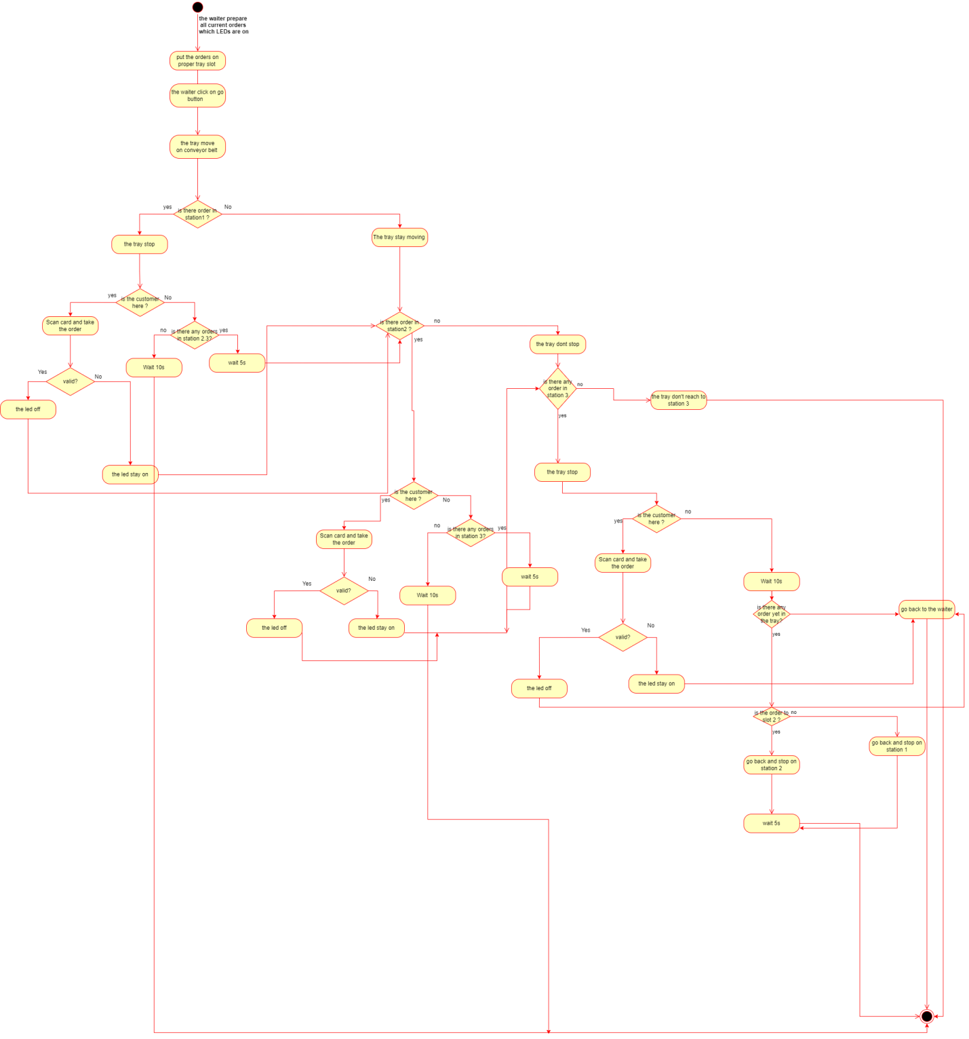

Figure 27 Tray activity diagram

### Architectural diagram

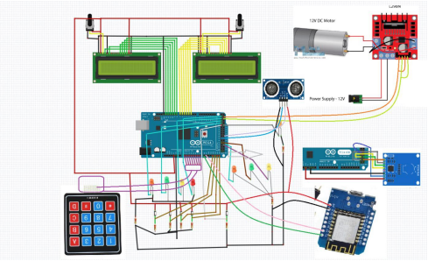

Figure 28 Architectural diagram

# **CHAPTER 4: RESULTS AND DISCUSSIONS**

## Results

After prolonged work on our project (smart restaurant), which lasted for eight months of planning and research, and then starting the application, we were able to get the result we wanted with an almost excellent percentage.

Our project, whose idea revolves around developing the method of requesting and obtaining orders in cafes, and what is applied in cafes is also applied in restaurants.

First of all, the main idea in our project revolves around establishing a system for transferring orders so that the order reaches each customer's slots based on the method of his request, which we will explain accordingly, and we have succeeded in that. The reason for this idea, as we mentioned, is the development of obtaining applications.

First, we kept the traditional method of ordering, which is manual, so that the customer requests his order from the waiter, taking into account those who do not have the ability to keep up with technology, such as the elderly, with a little modification, which is placing the order on the conveyor belt until it reaches the specified slot of the traditional order.

The second method that we followed is to order the order via the keyboard system, then the order is displayed at the waiter's screen. The waiter brings it and puts it on the conveyor belt to reach the place designated for customers who order by the system.

The third method that we followed is ordering through the mobile application, as our system is equipped with Wi-Fi and the Firebase system. After the customer orders his order, the waiter checks the orders that were ordered through the mobile application, then he prepares the order and puts it on the conveyor belt, as in the previous methods.

We have succeeded in obtaining the result we want from the previous request methods.

The idea that we also wanted to apply is the existence of a scanning card that the customer owns to take his order from the place specified for him, so as not to mix orders and not to make a mistake by taking another customer’s order. The idea of the card did not work for us completely because it is linked with the idea of having a sensor to make sure whether the customer inserted his hand to take his order or not, which, following the result, turns off the tray light or stays on.

The idea that we also wanted to apply is the existence of a scanning card that the customer owns to take his order from the place specified for him, so as not to mix orders and not to make a mistake by taking another customer’s order.

The idea of the card did not work for us completely because it is linked with the idea of having a sensor to make sure whether the customer inserted his hand to take his order or not, which, following the result, turns off the tray light or stays on.

The steps that were planned, when the box arrives, the customer scans the card, then takes his order, and the sensor senses entering his hand, then the light turns off. The result was that the sensor sensed the hand, but the system did not recognize that the card had been scanned, and the light remained on. The proof of the success of the sensor idea is that when we inserted our hand into another customer's tray, the light on the waiter system is go on, which indicates an attempt to take another customer's order.

Here are some pictures showing the result of the project:

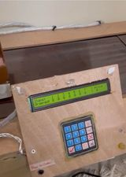 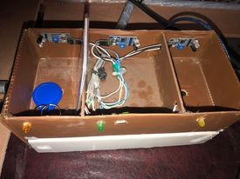

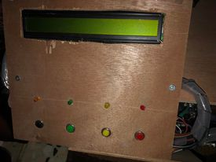

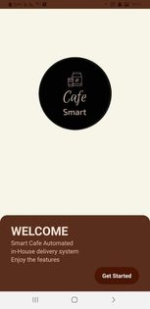 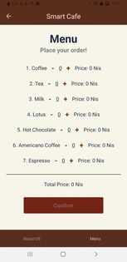

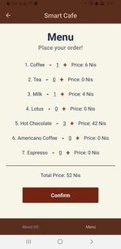 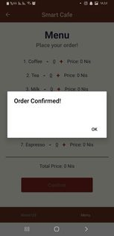 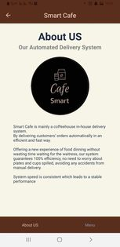

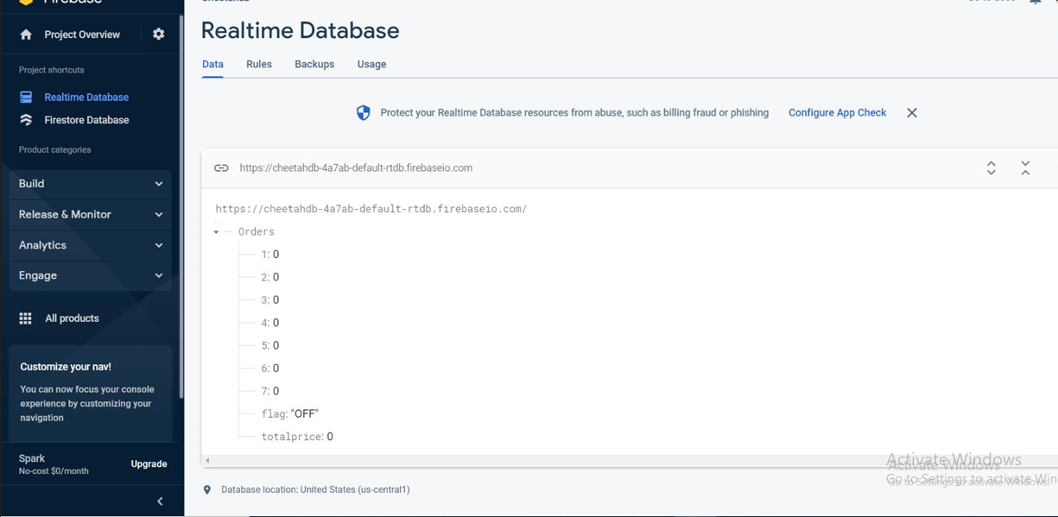

Learn more at Appendix B

## Discussions

Based on the work in our project, we were able to clarify the principle of our system's working well and to make a prototype showing our system. Through the previous works, we were able to know the great benefit desired from our project, and if a restaurant like it is built in Palestine, it will certainly attract people's attention to it.

Based on the algorithms that have been built, it shows us the principle of the system’s work, as it is clear that our system depends on the automated transmission system for orders to save time and effort and achieve high efficiency, as through the mobile application or the customer system, the customer can request his order and wait in his station to get On his own request, taking into account the preservation of the traditional method for those who do not have the ability to use technology.

The system also explains here the principle of the waiter's work, which does not have to wait all the time, as it prepares the customer's request only when the order notification reaches him.

The algorithms and charts created show us the system of work of the carrier, which is to go through all the departments and wait for a period of time until the customer can receive his order, and to maintain security by the customer not being able to receive his order without scanning the correct card.

And we take into account that orders that the customer requests through the mobile application does not appear directly on the waiter’s screen, because a defect occurs in the project system due to the continuous examination process, so the waiter checks the customer’s request through the mobile when he receives an order by other methods or whenever he wants.

After the result we obtained, it shows us the steps that the system takes gradually from the moment the customer requests his order until the moment he reaches it, taking into account the return to the customer who did not take his request as an opportunity. Where the customer requests his order in one of the three ways, the orders that were ordered via the keyboard system or the phone application appear on the waiter's screen, then the waiter prepares the order and places it on the conveyor tray, so that it arrives at the slot of each customer in order. The conveyor belt does not stop at the slot of the customer who did not order.

## Challenges, modifications and problems

We faced many challenges represented by multiple circumstances, and several changes occurred on our project.

1. Connecting and wiring the units and equipment was a big challenge. We needed to change the power supply for the project twice from 12V to 9V and then back to 12V because it tends to work better at higher voltages, is compatible with the conveyor design, and the nine volts slowed the belt movement significantly.
2. When we created the mobile application, we needed an ESP module to establish communication between the system and the mobile application. It took time and effort to connect the application to Real-time data on Firebase, then connect Firebase to the ESP module to send customer requests to the application. And we had a problem getting the system to be able to recognize the Wi-Fi network.
3. We encountered a problem with scanning the card that the customer owned, and it was difficult for us because it required additional money and time, and we did not have enough time to fix the problem, and this led to not working all the functions in our project 100%.
4. We had planned that the LCD screen shall display our customers' order when the cashier push the Intended button depending on the lighted led in real time to make the order and place it on the tray . But our result changed so that the light of the application does not light up when a request arrives, but the waiter checks for the existence of a request by pressing the button, then the system starts checking the firebase website and the light starts blinking and confirms if there is a request and turns off otherwise.

# **CHAPTER 5: Project Management**

## Tasks, Schedule and Milestones

This section will list all of the tasks that we did from the start of the project to the end, as well as the duration of each task and the overall time it took to finish the project.

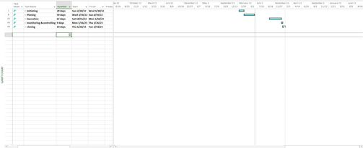

Figure 29 MS Project 1

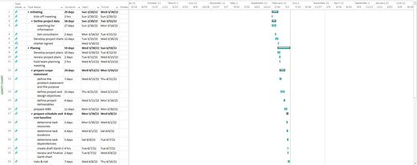

Figure 30 MS - Project 2

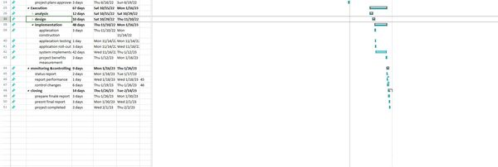

Figure 31 MS-Project3

# 5.2 Resources and Cost Management

|  |  |  |
| --- | --- | --- |
| Item | #Unit | Unit Cost |
| Conveyor belt | 1 | 250 nis |
| ln298 driver | 1 | 24 nis |
| LCD | 2 | 20 nis |
| Arduino mega | 1 | 80 nis |
| IR module | 1 | 16 nis |
| LED | 8 | 1,5 nis |
| Push Button | 2 | 14 nis |
| RFID Reader | 3 | 56 nis |
| Keypad | 1 | 6 nis |
| Power supply | 1 | 73 nis |
| ESP | 1 | 35 nis |
| Ultrasonic | 1 | 16 nis |
| Wire | Nearly 50 | 2 nis |
| carpenter cost |  | 300 nis |
| Total Senior Project Estimate | 1158 | |

Table total cost

## Lessons Learned

1. The importance of technology in our lives:

After a long search for problems and after finding our idea, we found that there are many problems that can be solved with technology as well, so we realized the great importance of technology in our time.

1. Time management:

We realized the importance of time and that lost time had a negative impact on our lives, forcing us to greatly compress our lives and take time from our daily lives, so we must Commitment to the time schedule that was set in advance.

1. The importance of studying previous works:

It is very important to study the work related to our project, to benefit from it and understand the problem well, and it is possible to try to develop on it to get an excellent job and amazing results, and not having to go back to work and repeat it, which consumes us in terms of time and costs as well.

1. The importance of the team:

We found the greatest importance of working with a team according to correct basics based on the division of labor among us, understanding and cooperation together, which brings us benefits in terms of time, investing new ideas in our work, and increasing our awareness of the existence of the least possible number of mistakes.

# **CHAPTER 6: Impact of the engineering solution**

## Economical, Societal and Global

**Economics impact of the product:**

Compared with other projects, the cost of our project is rather low and there is no negative or positive impact on the economy.

**Social impact of the product:**

It has a positive effect, because it serves a large number of people, as it saves time for the waiter, in addition to providing great convenience to the customer so that they do not waste their time waiting for the employees to fulfill their request , and do not get wrong in their request. The system worked to reduce the boring daily routine work of the employees that causes them difficulties, which worked to provide them with comfort.

## Environmental and Ethical

**Environmental impact of the product: الترجم:ة**

There is no kind of impact in our project on the environment because it does not pollute the ecosystem and does not generate air pollution gases, as only electric energy is used and there is no negative impact on the environment. It does not deplete natural resources in any way.

# **CHAPTER 7: CONCLUSIONS and RECOMMENDATIONS**

## Summary of Achievements of the Project Objectives

"Smart Restaurant" was introduced as a development system for restaurants based mainly on technology to help solve the problem of regularity for the customer and the waiter as well. Giving assistance to individuals in our society especially since we are an occupied country is very important and may be seen as a moral responsibility for us as engineers, so the desired result is to create a system that facilitates people's lives and here allows them to place their order and get without waiting for long time and errors in their orders with others. Our system aims to address the most important issues people face when they go to restaurants. In addition, we will increase people's desire to go to such a developed restaurant.

The benefits of a "smart restaurant" are:

1. Their ability to place their order through a mobile application or a customer system.
2. Enabling them to receive their request in person to obtain maximum satisfaction.
3. It reduces the possibility of error in their order with others, as is the case in many restaurants nowadays.
4. Allow them to develop themselves technology wherever they will deal with technology primarily.
5. Ease of use, no need to train people to use the system, it is quite clear.

A “smart restaurant” is supposed to make life easier for people through an automated ordering and receiving system.

## New Skills and Experiences Learnt

After completing Project II, we acquired several skills:

1. How to deal with more programs (MS Project, Word, Drawio, simulation program, Arduino IDE , vsCode).
2. Work on creativity at work.
3. Create ideas to solve the problems of the current time easily.
4. How to solve community problems through human-friendly systems and solutions.

Also we gained several experiences:

1. Problem Solving:

During the work, we encountered several problems, such as Word formats, programming the units and trying to connect them together, trying to link the mobile application with the system, and we tried to solve them in several ways. We managed the time, so we divided the work between us and then reviewed it together.

1. Working as a team:

We do not deny that we can work alone, but we will not reach the degree of accuracy and creativity that exists in working with teams, as we divide the tasks between us and help each other. We were able to complete the work faster and better.

1. Time Management:

We divided the work among us and distributed the tasks that suited each one of us. Our time was very limited and we faced a delay in starting work, but by organizing our time and helping each other, we were able to complete it in the required time.

## Recommendations for Future Work

We hope in the future that the project will be adopted in our country because of its advantages and ease of use.

We will explain some of the basic features that can be added to the project to make it more advanced, they are:

The first feature is to enable the automatic payment system, which will save a lot of time in addition to the valuable time already.

The second feature is to link the telephone system with the kitchen so that the chefs can process orders immediately without waiting for the waiter to tell them.

The third feature is to make more than one linkage together through a huge database, and link it with the main branch to know the percentage of consumption and profits.

The fourth feature is to create a customer evaluation system to give us a feedback about our restaurant.

# REFERENCES:

1. https://socialhospitality.com/2014/09/smart-restaurants-technology/Watermark 200SS soil moisture sensor specification manual. Available at http://www.irrometer.com/sensors.html
2. https://www.researchgate.net/publication/356682466_A_SMART_RESTAURANT_MENU_ORDERING_SYSTEM_USING_ARDUINO
3. Jakhete, M. D., & Mankar, P. C. (2015). Implementation of Smart Restaurant with e-menu Card. *International Journal of computer applications*, *119*(21).‏
4. Huang, G. S., & Lu, Y. J. (2017, November). To build a smart unmanned restaurant with multi-mobile robots. In *2017 International Automatic Control Conference (CACS)* (pp. 1-6). IEEE.
5. <https://www.monk-conveyors.com/belt-conveyors/>

1. <https://www.smart-prototyping.com/L298N-Dual-H-bridge-Motor-Driver-Board>

1. <https://www.hackster.io/remnis/h-bridge-for-your-robot-025ae8>

1. <https://circuit.rocks/arduino-mega-adk-r3.html>

1. <https://www.winstar.com.tw/products/character-lcd-display-module/40x2-lcd.html>

1. <https://www.zoodmall.iq/product/17014973/10pcs-ir-infrared-obstacle-avoidance-sensor-module-for-smart-car-robot-3wire-reflective-photoelectric-for-car-robot/>

1. <https://shopae3.blacktapemusic.com/category?name=white%20led>

1. <http://synacorp.my/v3/en/push-buttons/1707-476-22mm-push-button-self-resetting-xb2-ea.html>

1. <https://www.elecrow.com/rfid-reader-with-cards-kit-1356mhz-p-756.html>

1. <https://geeksvalley.com/en/product/matrix-keypad/>

1. <https://www.circuitspecialists.com/9-volt-17-amp-power-supply.html>

1. [tinyosshop.com/index.php?route=product/product&product_id=908](https://www.tinyosshop.com/index.php?route=product/product&product_id=908)

1. <https://www.sparkfun.com/products/15569>

1. <https://www.sparkfun.com/products/11026>

# APPENDICES

## Appendix A:

**Hardware:**

**Appendix A.**1

Conveyor belt:

The conveyor belt is a ring belt that is operated by one pulley and wrapped around it, the second pulley on which the belt rests only means for support. It is driven by the electric motor. The pulley that powers the conveyor belt is referred to as the drive pulley.

The engine on the conveyor belt provides the pulley with energy to make it rotate, to move the belt. This engine derives the energy from the power supply of the system and is equipped with gearbox to increase the torque.

The conveyor belt we used in our project to transfer orders to the slot of each customer as we explained. That is, it is transferred from point A (the waiter) to the point B (the customer).

Our belt works in two directions in front and back.

The conveyor belt movement is controlled by controlling the motor that we control through H-Bridge that programmed by the Arduino.

 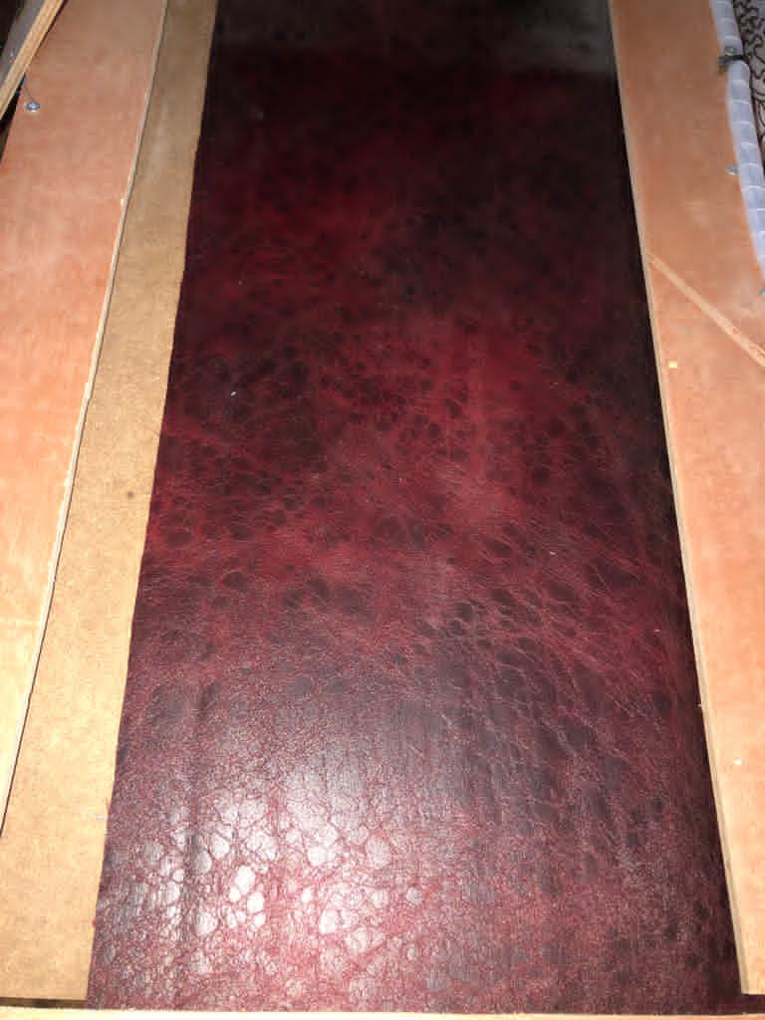

**Appendix A.**2

Ln298 Driver :

The L298N engine operating unit that we used a high -power driving unit for DC Motors driving. This unit consists of the L298 engine and 78m05 5V regulator, which turns voltage into five volts, because it receives 12 volts of the power supply.

This engine controls the movement of the motor on the conveyor belt through the Arduino.

Here we used the whole H-bridge(Ln298 Driver) because it is connected to the DC motor that has a high ampere, so it contains a motor A and motor A and we both used .

We connected it with pins 23,25 high and low digital- output on Arduino.

 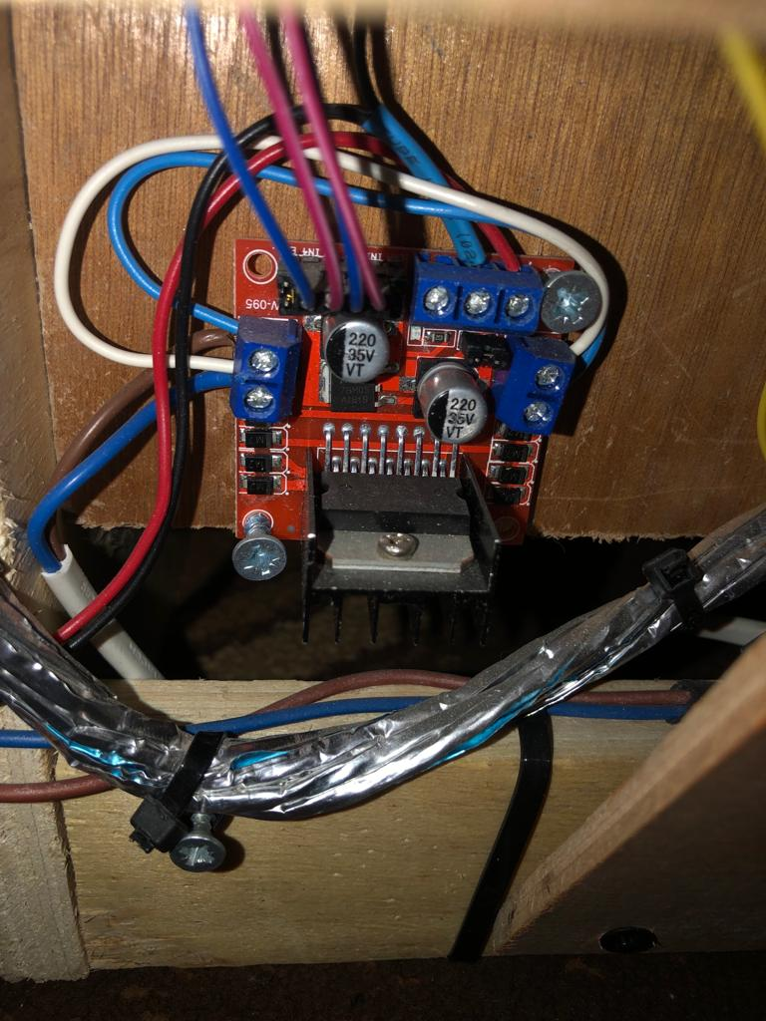

**Appendix A.3:**

Arduino Mega:

The Arduino Mega that we used is a microcontroller board. It has 54 digital input/output pins, 16 analog inputs. Each of this pins was interrupted with a specific unit.

We used the Arduino to control all of our system**.**

 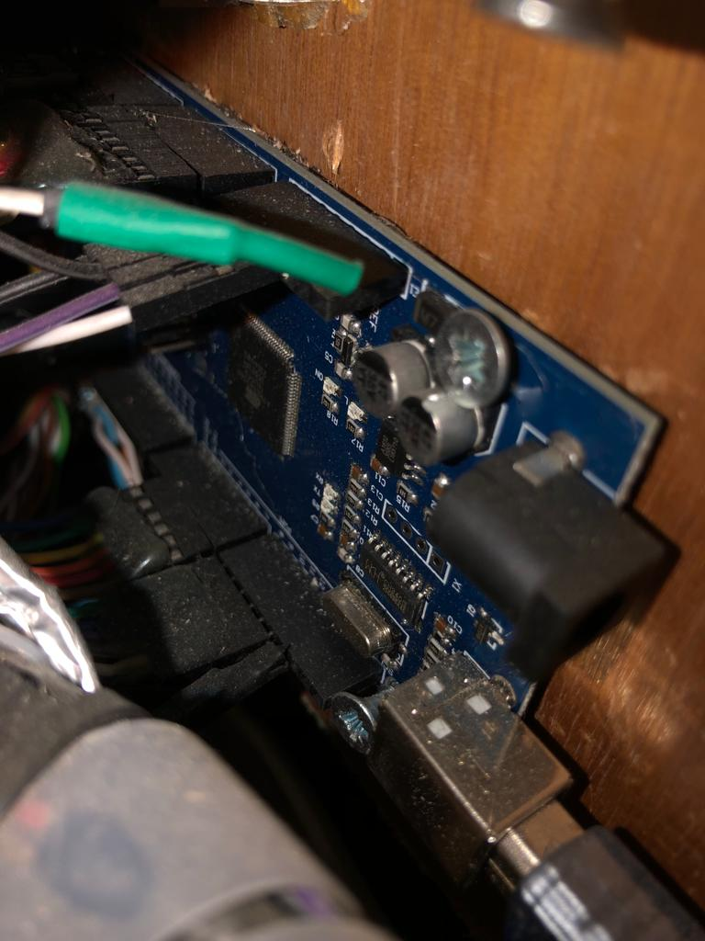

**Appendix A.4:**

LCD 40*2 :

Our project contains two pieces of LCD, one for the customer and another for the waiter.

The customer screen to display the orders he request and show the price and quantity. As for the waiter screen, it is also to show the customer's orders and quantity.

We connected the 2 LCD with 12 pins on the Arduino (from 2-to-13 digital pins) , each LCD with 6 pins, and we used another 2 pins for vcc and ground.

 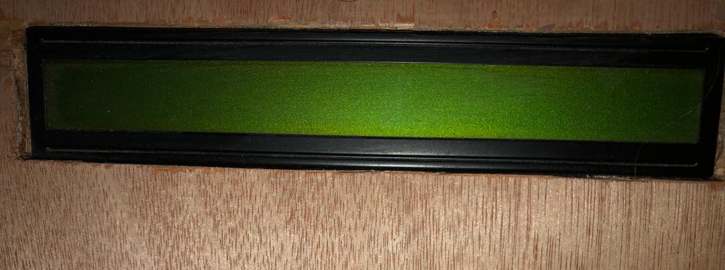

**Appendix A.5:**

IR Module:

We used the infrared sensor (IR), an electronic device that measures and discovers infrared radiation in its surrounding environment. In our project, it senses the customer's hand when it is inserted into the tray to take his request.

Once the customer enters his hand and is expressed by this sensor, a beam comes out of IR Emitter to IR Receiver and send a sign for the Arduino, and this sign is digital output from the sensor and is considered to be an input for Arduino. This sensor contains a changing resistance in which you can adjust the sensitivity of the sensor.

We connected the IR-Module with digital pins 43,44,45 on Arduino and another 2 pins for Vcc and ground of course.

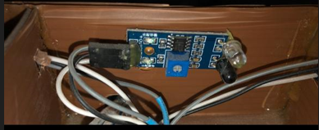

**Appendix A.6:**

LED**:**

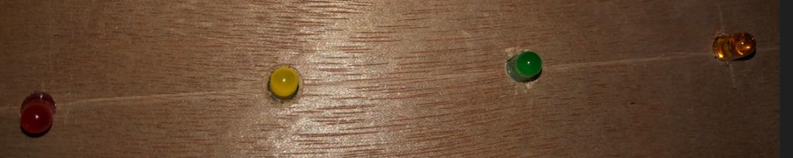

**Appendix A.7 :**Push Button :

The first case that we used in the button is for the customer to start the order process. So that it sends a signal to the Arduino to start the request and lights the LED next to the keyboard

The second case is for the waiter, so that there are two of them to display the customer's request on his screen and the other button to send the tray.

We connected the buttons for waiter with pins A12, A13, A14, A15 on Arduino, and the button of customer with digital pin 30.

 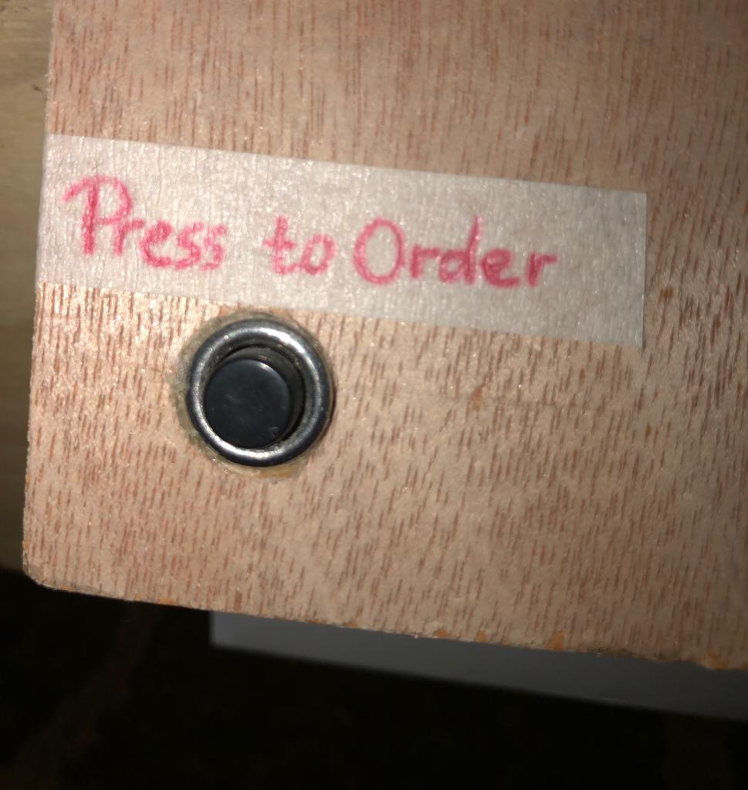

**Appendix A.8:**

RFID Reader:

The RFID system is consist of two components: the RFID reader and tags. The RFID reader consists of an antenna and a reader/writer. MFRC522 from NXP is an example of that circuit.In our system we use it To make the order secure, we will put an RFID module in every slot, to let the customer scan it in his own slot, Every card only scan its own slot.

 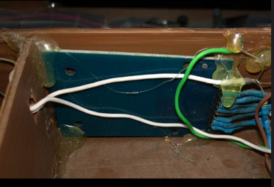 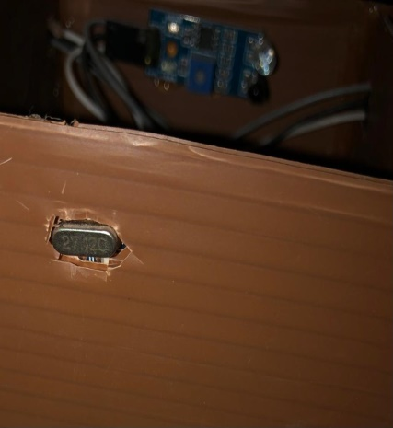

**Appendix A.9:**

Keypad 4*4:

This matrix keypad 4 X 4 has 16 buttons, to scan the pad we need 8 pins from Arduino (4 pins for rows,4 pin for columns ).

We will use it In our system to enable the customers to place their orders since that Each button, when pressed, is programmed to perform an appropriate action to complete the ordering process.

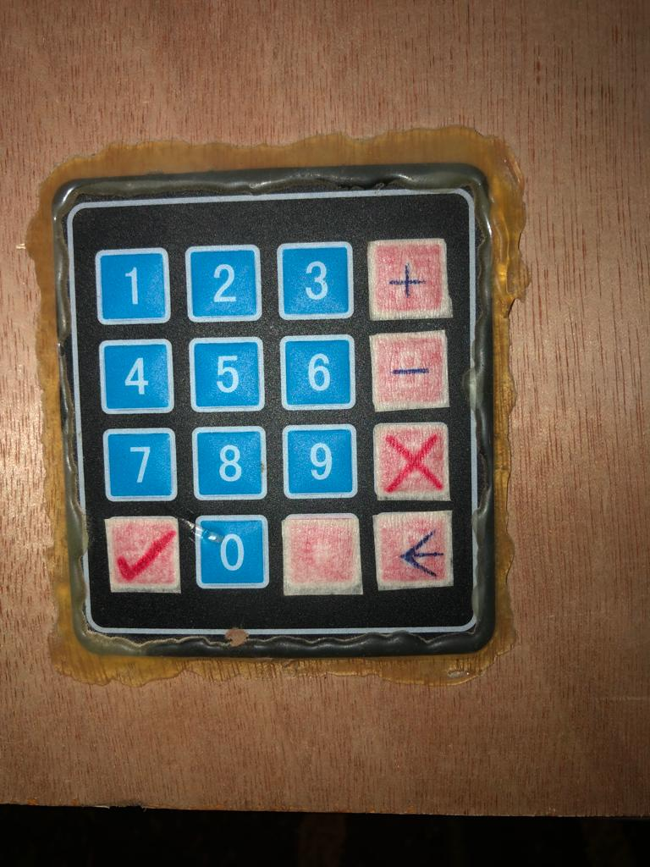

**Appendix A.10:**

Power Supply: This 12V power supply.

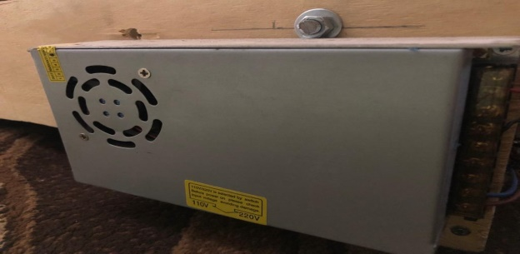

**Appendix A.11:**

Ultrasonic:

sensor that measures the distance depending on the ultrasound reflection, where the sensor sends an ultrasonic wave (Ping) to collide and reflect back to the sensor (Echo).

We used this sensor in our project to be able to know the location of the tray and stop it in the right place. Its have 4 pins VCC,GND,TRIGGER ,ECHO .

We connect the TRIGGER to pin 42,ECHO to pin 41.The trigger pin is used to trigger the ultrasonic pulses. The echo pin becomes high when the ultrasound is transmitted and stay high until the sensor receives an echo, after that it goes down. By measuring the time the Echo pin stay high, the distance can be calculated.

Please note that the frequency of the sound produced by the sensor is very high (“ultrasonic”) so that humans cannot hear it.

 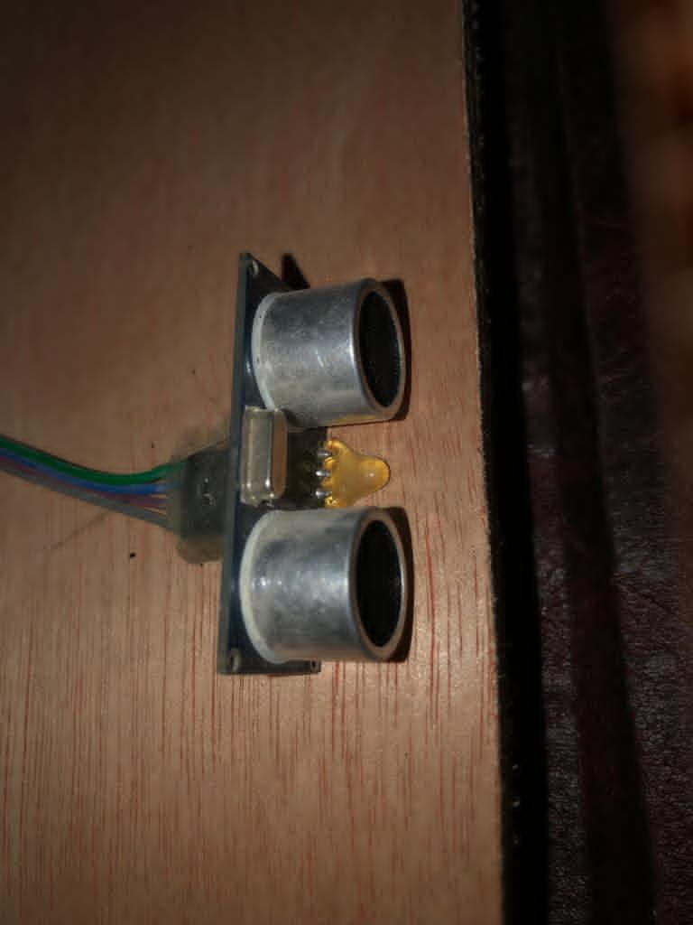

**Appendix A.12:**

ESp8266 Module:

A module for connecting the Firebase real-time database to the system using Wi-Fi. we use Arduino IDE to program the ESP8266 CPU and its Wi-Fi components.

we connect the TX with A8 and the RX with A9, its communicates with Arduino via a serial connection .

by this chip we can get the order information which made by the application user to the waiter LCD.



**Appendix A.13:**

Wires

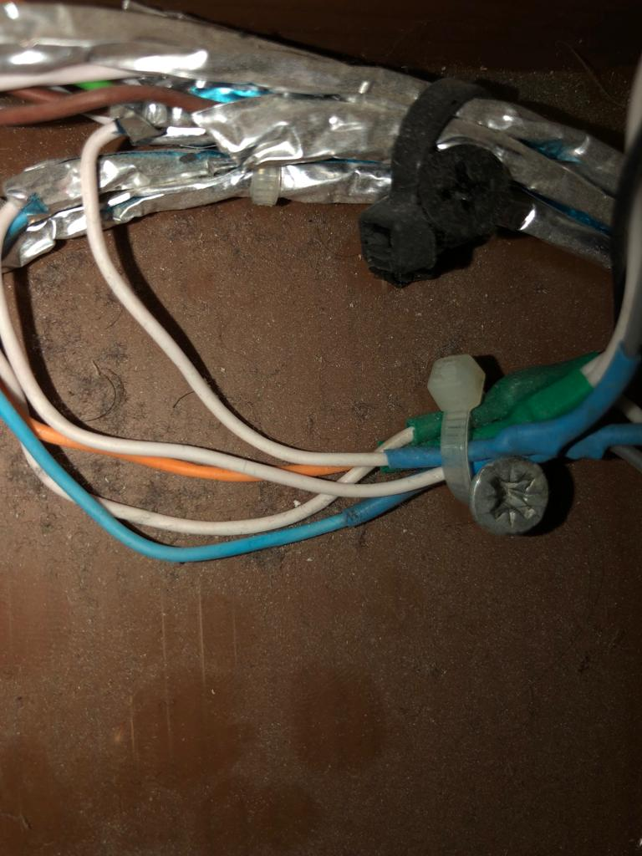 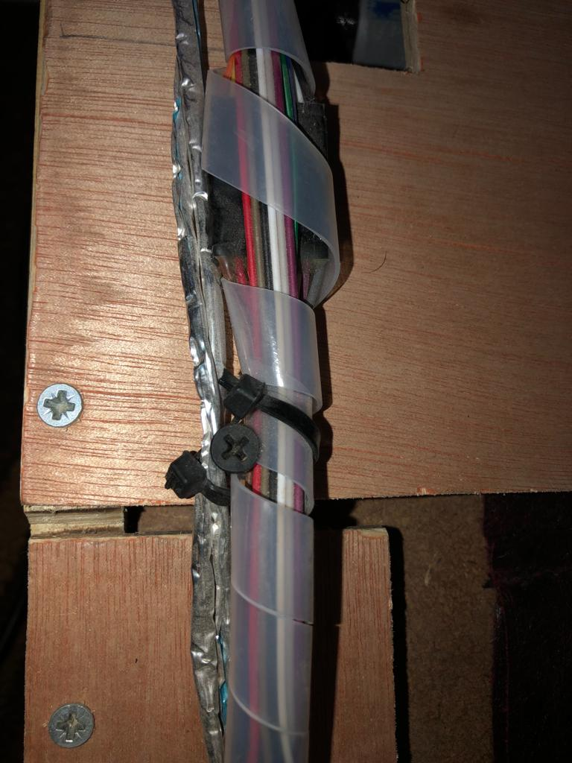

## APPENDIX B:

Software:

The second method used in our project to request our orders is the mobile application, as it allows the customer to request his order in a simple way and easy use.

When you open the application, there is our logo, a welcome phrase and "Get Started" to start using the application.

The screen here shows us a list of product names, numbered from one to seven. Next to each product, there is the quantity and price. At first, their value is zero before ordering.

 

The screen here shows us the order quantity, the price of each order, and the total price as well.

There is a "Confirm" to confirm the customer's order. Then, after confirming the request, we will see a message confirming the request.

At the bottom of the screen, two options appear, "About Us" to know our cafe, and the other "Menu" to return to the order list.

  

Here the data base is initially zero before the customer confirms his request, after confirmation it changes to show the quantity and total price.



The application is written by React native using VSCode. And we use Firebase real-time for database.